**30 Day Plank Challenge – Goal: 1 Minute Plank!**

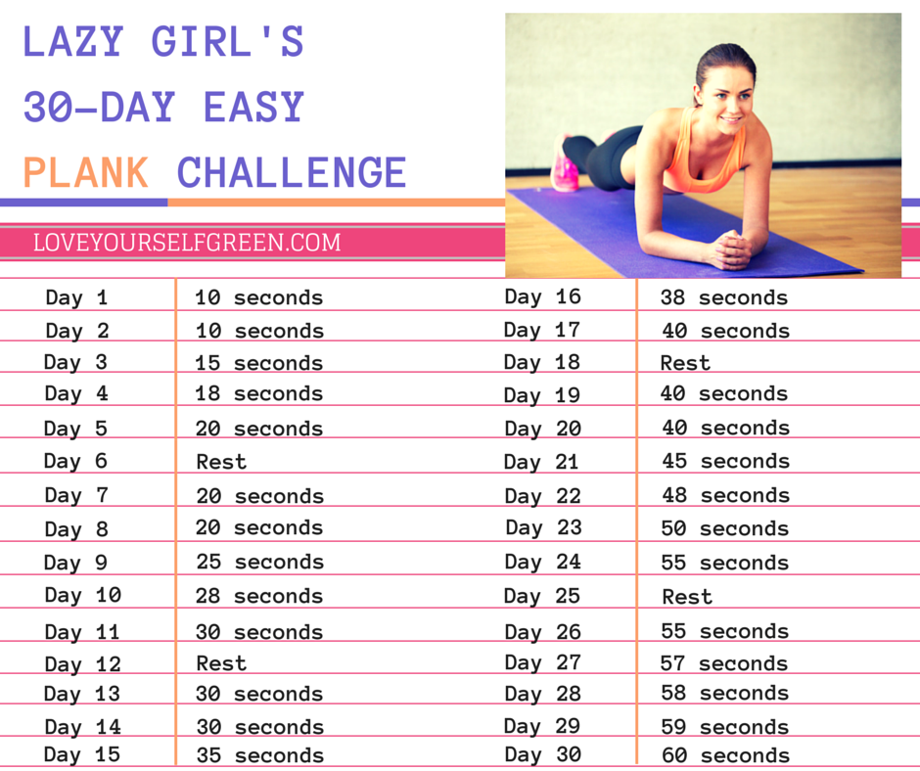

**30 Day Plank Challenge – Goal: 3 Minute Plank!**

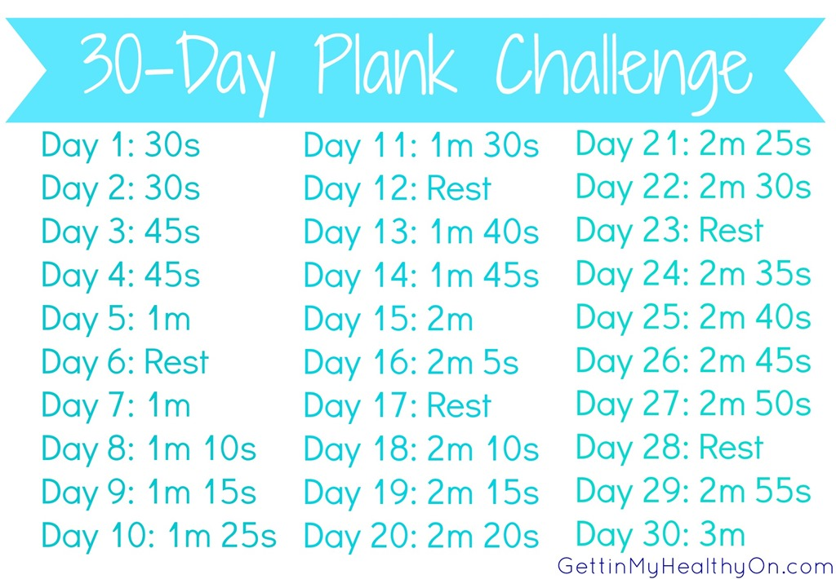

**30 Day Plank Challenge – Goal: 5 Minute Plank!**

